[13:-5]

(array([ -9.40467525, 19.42423684]), array([[ 0.00047107, -0.00431605],

[-0.00431605, 0.04048206]])) 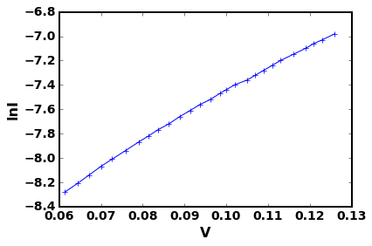

[13:-5]

(array([ -9.39052345, 19.29853971]), array([[ 0.000435 , -0.00397522],

[-0.00397522, 0.03712323]]))

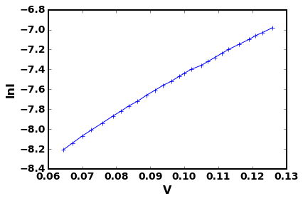

[15:-5]

(array([ -9.3821647 , 19.22454901]), array([[ 0.00042105, -0.00384181],

[-0.00384181, 0.03578626]]))

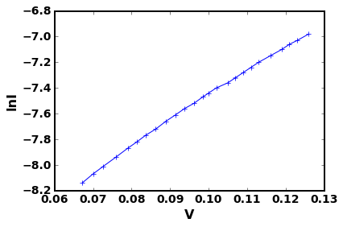

[16:-5]

(array([ -9.36847592, 19.10375018]), array([[ 0.00039876, -0.00362699],

[-0.00362699, 0.03362009]]))

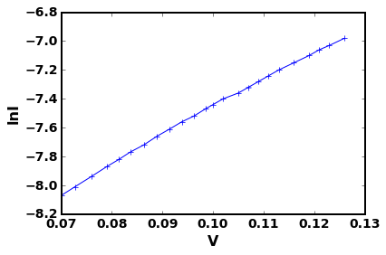

[17:-5]

(array([ -9.34945342, 18.93656772]), array([[ 0.00037877, -0.00342665],

[-0.00342665, 0.03151193]]))

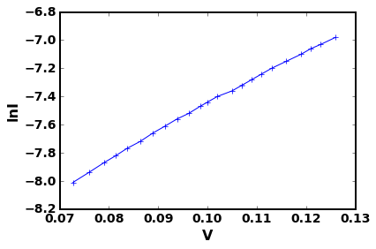

[18:-5] (array([ -9.32563981, 18.72791136]), array([[ 0.00032634, -0.0029358 ],

[-0.0029358 , 0.02677679]])) 